REPUBLIC OF RWANDA
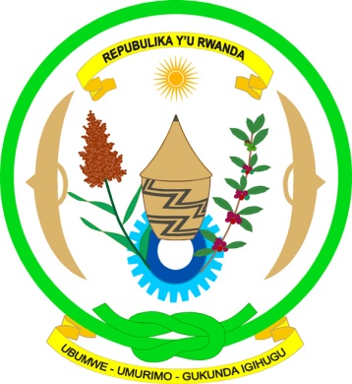
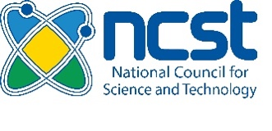

NATIONAL COUNCIL FOR
SCIENCE AND TECHNOLOGY

RESEARCH PERMIT
PROGRESS REPORT TEMPLATE

The National Council for Science and Technology (NCST) requires all approved research permit applicants to submit progress report, as well as final report. This template is designed to provide a summary of activities performed for an approved research permit.

The report is expected to be between 2000-2500 words, excluding the bibliography (references) page, with single space, Times New Roman or Arial Font, 1.8 cm margins and size 12.

Graphs, figures and any other information may be attached to the same report (as annex(es). The following is a suggested template:

- Project Information
Research permit number:
Research permit period:
Title of Project:
Principle Investigators (PIs):
Co-investigators (Co-PIs):
Main Institution:
Country of Residence:
Host Institution (in Rwanda):
Name and contacts (email + telephone) of Local Supervisor:
Research Area:
Field of Interest:
Project/Research Start Date:
Project/Research End Date:
- Summary of the research study
Provide an Executive summary of the project research with objectives and excepted outcomes (max 300 words).
…… ….. ………
- Status of the research study

Provide a description of progress made (what has been achieved in terms for example, data collection, data analysis and results, community engagement and outreach) versus the planned objectives and activities.

State challenges encountered (if any) and how they have been addressed.
State planned activities not completed and what reasons? (max 800 words).
…… ….. ………

- Findings
Provide a brief description of research study findings with respective indicators (max 500 words).
…… ….. ………

- Research study dissemination
Provide a description of research study dissemination in terms publication, seminars, workshop, training, etc. (max 400 words).
…… ….. ………

- Future plan and timeline
Provide a brief description of next steps for future plan with timeline (max 500 words).
…… ….. ………

- Any additional information
Provide any additional information in terms of other achievements (max 300 words).
…… ….. ………

In case addition information is required please contact:
Email: researchpermit@ncst.gov.rw
Telephone: +250 781 030 798

